Pupil premium strategy statement – Samuel Ward Academy 2024-2025
This statement details our school’s use of pupil premium (and recovery premium) funding to help improve the attainment of our disadvantaged pupils.
It outlines our pupil premium strategy, how we intend to spend the funding in this academic year and the outcomes for disadvantaged pupils last academic year.

School overview
Detail | Data
Number of pupils in school | 1033 (excl Sixth Form)
Proportion (%) of pupil premium eligible pupils | 17%
Academic year/years that our current pupil premium strategy plan covers (3 year plans are recommended – you must still publish an updated statement each academic year) | 2024-2027
Date this statement was published | November 2024
Date on which it will be reviewed | December 2024
Statement authorised by | Tom Johnston
Pupil premium lead | Vicki Eldred
Governor / Trustee lead | Sue Kehr

Funding overview
Detail | Amount
Pupil premium funding allocation this academic year | £182,925.00
Pupil premium funding carried forward from previous years (enter £0 if not applicable) | £0
Total budget for this academic year  If your school is an academy in a trust that pools this funding, state the amount available to your school this academic year | 2025/2026 £182,663.92  2026/2027 £183,395.32

Part A: Pupil premium strategy plan

Statement of intent
Our expectation at Samuel Ward Academy is that all pupils, irrespective of background or the challenges they face, become strong readers and accumulate the cultural capital needed to succeed in modern Britain. We will use pupil premium funding to help us improve and sustain higher attainment for disadvantaged students until their achievement is at least as strong as non-disadvantaged students nationally. During the period of this strategy plan we will focus on the key challenges that are preventing our disadvantaged pupils from attaining well: attendance, reading, and wider soft skills around relationships. Our approach will consider each student’s individual needs, rooted in robust diagnostic assessment, not assumptions about the impact of disadvantage.
During the next three years, 2024-2027, we will:
• improve students’ attendance
• improve the precision and fluency with which students read
• foster a safe and supportive environment where students receive the right support at the right time
• further development students’ social skills and relationship building

Challenges
This details the key challenges to achievement that we have identified among our disadvantaged pupils.
Challenge number | Detail of challenge
1 | Attendance  Our assessments, discussions and observations show that our disadvantaged students attend school less than their non-disadvantaged peers- a situation which has worsened since the Covid-19 pandemic.  In the 2024 academic year to date the attendance figures for students in Years 7 to 11 are as follows:  AUTUMN TERM 24-25  Year 7 PP students: 94.1% Non PP: 94.2%  Year 8 PP students: 85.2% Non PP: 92.6%  Year 9 PP students: 72.9% Non PP: 92.6%  Year 10 PP students: 66.8% Non PP: 92.3%  Year 11 PP students: 78.6% Non PP: 91.8%  42% of PP students (Year to date) are Persistently Absent (PA)
2 | Reading  Our assessments, discussions and observations show that our disadvantaged students are greater risk of weak reading accuracy and fluency.  In 2024 NGRT assessments show the proportion of students with a standardised age score (SAS) below 90 as follows:  Year 7 PP: 31% Non-PP: 19%  Year 8 PP: 22% Non-PP: 17%  Year 9 PP: 48% Non-PP: 19%
3 | Social and emotional issues and mental health  Our assessments, discussions and observations show that our disadvantaged students are at disproportionate risk of a range of issues around mental health, anxiety and relationships. Our disadvantaged students, on average, receive fewer rewards and experience a greater frequency of sanctions for poor conduct compared to their peers.  In 2024)  Suspension data: Year to Date AUTUMN 24  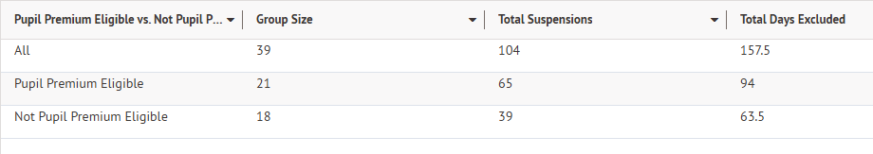
4 | Achievement  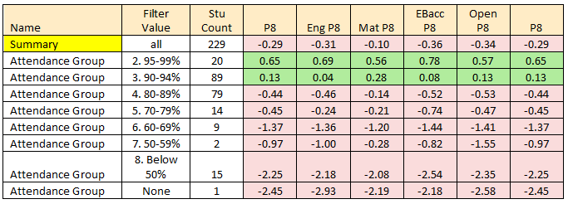  The link to attendance is clear from the results from Summer 24. Strong attendance led to better attainment and the correlation between poor attendance and our PP students is great. The strategy must focus on student attendance at school and then the targeted intervention of those students assessed to be in need of further support. Greater attendance of all students ensures that any need is identified and acted upon at an early stage to ensure the best outcomes for all students.  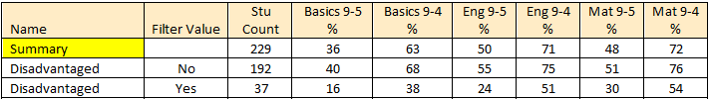  As shown above, the results from Summer 2024 GCSE show less than 50% of PP year 11 students achieved a 4 in English AND Maths. Maths have a larger proportion of children achieving a 4 with 54% over English with 51%. Greater focus must go into students hitting one of Maths and English but missing the other.

Intended outcomes
This explains the outcomes we are aiming for by the end of our current strategy plan, and how we will measure whether they have been achieved.
Intended outcome | Success criteria
Improve the attendance of disadvantaged students through a school-wide coordinated approach. | Reduce the gap in attendance between disadvantaged and wider cohort year on year. Persistent absence of disadvantaged students to reduce by 20% year on year.
Improve the accuracy and fluency with which disadvantaged students read. | Proportion of students in years 7 and 8 with an SAS below 90 to halve year on year. All cohort to make greater gains in reading age than their increase in chronological age.
Improve disadvantaged students’ wellbeing and behaviour through enhanced pastoral support and self-regulation. | Student, parent and teacher voice will indicate reduced incidents of students requiring coregulation and adult support. Academic resilience will be evident, and students will be able to talk about strategies they employ to self-manage their worries and feelings.  Target fixed term exclusion rate to be below 10% for PP students.
Disadvantaged students to make good progress across the curriculum. | Assessment and tracking data at KS3 shows gaps between disadvantaged students and wider cohort narrowing over time.  In Year 11, disadvantaged cohort to achieve in line with national averages.

Activity in this academic year
This details how we intend to spend our pupil premium (and recovery premium) funding this academic year to address the challenges listed above.

Teaching (for example, CPD, recruitment and retention)
Budgeted cost: £ 60,000]
Activity | Evidence that supports this approach | Challenge number(s) addressed
Provide a wide-ranging CPD offer for all staff including trauma awareness and improving our universal offer (beneficial to all but vital to some) | https://educationendowmentfoundation.org.uk/education-evidence/guidance-reports/behaviour  https://educationendowmentfoundation.org.uk/education-evidence/guidance-reports/effective-professional-development | 1,2,3,4
Providing resources and training to introduce develop and embed the tutor time reading programme | https://educationendowmentfoundation.org.uk/education-evidence/teaching-learning-toolkit/reading-comprehension-strategies | 2,4
School-wide instructional coaching programme and subscription to online platforms to facilitate sharing of best practice | https://educationendowmentfoundation.org.uk/education-evidence/guidance-reports/effective-professional-development | 1,2,3,4,

Targeted academic support (for example, tutoring, one-to-one support, structured interventions)
Budgeted cost: £ 60,000
Activity | Evidence that supports this approach | Challenge number(s) addressed
Additional pastoral support including School Counsellor and additional Inclusion  Officer to provide  enhanced mentoring,  safeguarding and  pastoral support | https://educationendowmentfoundation.org.uk/education-evidence/guidance-reports/behaviour  https://educationendowmentfoundation.org.uk/education-evidence/teaching-learning-toolkit/mentoring | 1, 3,
Additional interventions to enhance students’ reading | In 2024-2027 this will involve the Herts for Learning Literacy Project for students who are not assisted by SEND interventions. | 2, 4

Wider strategies (for example, related to attendance, behaviour, wellbeing)
Budgeted cost: £ [60,000]
Activity | Evidence that supports this approach | Challenge number(s) addressed
Restructure of Student services will develop relationships between Key Workers and families. This will have a positive impact on attendance and building links to break down any other barriers to learning. | https://educationendowmentfoundation.org.uk/education-evidence/teaching-learning-toolkit/parental-engagement#:~:text=Parental%20engagement%20approaches%20are%20typically,approaches%2C%20schools%20should%20consider%20implementation. | 1,3
Expand support for vulnerable students through provision such as “The Study” including further ELSA trained staff | https://educationendowmentfoundation.org.uk/education-evidence/guidance-reports/behaviour  https://www.traumainformedschools.co.uk/evidence-base | 1,2,3,4
Provision of resources to enable wide participation and accrual of cultural capital | These resources can include:  - Support for school trips and experiences  - Music lessons  - Uniform  - Revision resources  - Tutoring
Contingency | This is held for unforeseen circumstances and individual student need.

Total budgeted cost: £ [180,000]

Part B: Review of the previous academic year

Outcomes for disadvantaged pupils
Our previous strategy sought to improve students’ reading; attendance; achievement; and wellbeing. Following the pandemic all of these issues remain key challenges and are reflected in priorities for 2024-27.
Reading
All staff were trained in explicit vocabulary instruction and a whole-school approach to new vocabulary established. Interventions such as Spellzone, Lexia, Catchup Literacy, sound discovery enjoy considerable success- 82% of target students improved their standardised age score in reading and 85% in comprehension.
Next steps for 2024-27: Tutor time reading programme, Hackney Literacy Programme, focus shift to students who are not currently receiving Spellzone, Lexia, Catchup Literacy, Sound Discovery.
Attendance
As noted above, the gap in attendance between disadvantaged students and their peers remains a national concern and a key priority for leaders at SWA. In the 2022-23 academic year 37.9 per cent of disadvantaged students nationally were persistently absent. In 2023 we have introduced a new school-wide attendance strategy. Student attendance will be clearly tracked and the role of the form tutor is pivotal within this new model. Earlier identification of arising attendance issues will be paramount to children not slipping into poor attendance ahabits. A warm and welcoming approach to attendance is key so that families feel supported. Relationships between families and school is a key priority in improving attendance at school.
Achievement
Achievement of disadvantaged students lags behind that of their peers. This was less marked in the years where final grades were decided by Teacher Assessed grades and Centre Assessed grades. In 2023 the progress 8 score of disadvantaged students was -1.2 compared to -0.1 for their peers. The average attainment 8 score for disadvantaged students was 3.3 compared to 4.6 for their peers. The gaps were particularly noticeable in the Ebacc and Open elements. In 2023-24 we have made a number of improvements to tracking; timings and use of mock exams; curriculum; class routines and revision support. Indications following the final mock examination series are that disadvantaged students are on course to narrow the gap significantly compared to 2023.
Wellbeing
Introduction of the Study and the Wellbeing Way with ongoing Trauma training for all staff from the Mental Health Support Team have increased the effectiveness of support for vulnerable students. The challenge for 2024-27 is to increase capacity to meet the increasing demand. Changes to the interventions in the study have been adjusted and they now follow an Assess, Plan Do, Review model. Students have an intervention for a limited amount of time. This allows more children to have access to the study and for interventions to take a graduated response. The study is not able to offer interventions to children who are already receiving support from other agencies as this could cause a conflict. This has also given some capacity back to the interventions.

Externally provided programmes
Please include the names of any non-DfE programmes that you used your pupil premium (or recovery premium) to fund in the previous academic year.
Programme | Provider
Lexia Learning | https://www.lexialearning.com/
New Group Reading Test | https://www.gl-assessment.co.uk
National College | https://nationalcollege.com/secondary

